Issue date: |  | July 23, 2025
Closing date and time: |  | Responses need to be in before 12:00 pm Pacific Time on August 22nd, 2025. The Sunshine Coast Regional District (Regional District) will commence evaluation of responses after that time and reserves the right at its sole discretion to accept or reject any responses received after that time.
Submit bid to: |  | The Sunshine Coast Regional District , 1975 Field Road, Sechelt BC V0N 3A1, email address: submissions@scrd.ca
Contact for questions: |  | purchasing@scrd.ca  Any questions should be submitted in writing. Enquiries and responses will be recorded and may be distributed to all bidders at the Regional District’s discretion.
Introduction: |  | The Regional District is requesting quotations for gypsum container, removal and transportation services for gypsum received at the Pender Harbour Transfer Station and the Sechelt Landfill.  In 2024, approximately 67 tonnes of gypsum was received at the Sechelt Landfill and 14 tonnes was received at the Pender Harbour. These numbers best reflect our current material acceptance procedures; however, the Regional District does not guarantee the tonnage. A breakdown of gypsum received by month has been provided in Appendix 1.  Contractors are encouraged to visit the sites to help understand the site layout and access. Site maps are provided in Appendix 2 and 3. Current site hours of operation are included in Appendix 4.
Sechelt Landfill Requirements: |  | The Contractor will perform the service in accordance with the General Requirements and any site-specific requirements listed below.  The Contractor will:  - Transport gypsum, along with the materials manifest, from the Sechelt Landfill to our gypsum recycling service provider. The gypsum will need to be delivered within 24 hours from leaving the Sechelt Landfill.  - Provide two (2) 40 yard or equivalent containers at all times for the collection of gypsum. The Regional District may choose to utilize both containers or only one at their sole discretion.
Pender Harbour Transfer Station |  | The Contractor will perform the service in accordance with the General Requirements and any site-specific requirements listed below.  - Transport all gypsum, along with the materials manifest, received at the Pender Harbour Transfer Station to our gypsum recycling service provider. The gypsum will need to be delivered within 24 hours from leaving the Pender Harbour Transfer Station.  - Provide one (1) 40 yard or equivalent container at all times for the collection of gypsum.
General Responsibilities of the Contractor: |  | At both the Sechelt Landfill and the Pender Harbour Transfer Station, the Contractor will:  - Provide all materials, supervision, labour, equipment and all else necessary for, or incidental to, the proper execution of the work described in the quotation; and  - Provide the required containers for the collection of gypsum as outlined above;  - Provide response to gypsum removal request from Regional District staff within 24 hours, with gypsum removal within 72 hours, with removal to occur during then-current site operating hours (provided in Appendix 4);  - Conduct work at all times in a manner that does not interfere with or impede existing operations at the Sechelt Landfill or Pender Habour Transfer Station sites;  - Comply with then-current Ministry of Environment and Climate Change Strategy requirements and site safety procedures and regulations at all times;  - Provide a safety and access plan which meets the satisfaction of the Regional District;  - Cover the loads, or ensure the loads are secured, to prevent spillage of materials during transport in conformance with all transport regulations and local bylaws; and  - Leave marshalling areas at the sites clean and tidy.
General Requirement: Monthly Reporting Responsibilities: |  | For both the Sechelt Landfill and the Pender Harbour Transfer Station, the Contractor will provide individual site monthly reports in approved electronic format (Excel preferred) to the Regional District by the 15th of the following month as follows:  - Fuel and Greenhouse Gas (GHG) reporting (sample provided in Appendix 5).
General Requirements: Invoicing |  | For both the Sechelt Landfill and the Pender Harbour Transfer Station, the Contractor will provide individual documentation for each site in an approved electronic format via email to the Regional District:  - An individual monthly invoice for the Sechelt Landfill and the Pender Harbour Transfer Station.  - Individual Scale documentation from the Sechelt Landfill and the Pender Harbour transfer Station. The scale documentation will be signed by the Regional District Scale Attendant identifying number of containers removed when load removed.  - Associated tickets from the gypsum recycling facility.  - A monthly invoice summary sheet matching pickup and delivery dates; scale ticket number, container count for outbound loads; and gypsum recycling facility scale ticket number (sample is provided in Appendix 6.)
General Requirements of the Regional District: |  | At both the Sechelt Landfill and Pender Harbour Transfer Station, the Regional District will:  - Provide location for material pickup.  - Provide location for material delivery.  - Notify Contractor when material needs to be removed.  - Pay any applicable tipping or processing fees to the gypsum recycler.  - Provide all monthly reporting templates to Contractor
Term of the Contract |  | The term of the contract will be for a three (3) year period with the option to renew up to two (2) additional years at the sole discretion of the Regional District.  The anticipated commencement date for the service is November 1, 2025.
How to respond: |  | Please respond by completing this quotation page and the following pages 5 to 12. Prices quoted are to be exclusive of PST and GST. Quotes are to be FOB destination including all delivery charges. Bids should be submitted on this form and may be sent in hard copy, faxed, or emailed. Terms and conditions are on page 13.
Locations & Hours of Operation |  | Sechelt Landfill:  - 4901 Dusty Road, Sechelt, BC V0N 3A3  - Current hours of operation provided in Appendix 4  Pender Harbour Transfer Station:  - 5545 Garden Bay Road, Garden Bay, BC V0N 1S1  - Current hours of operation provided in Appendix 4  Gypsum Recycler:  - New West Gypsum – 38 Vulcan Street, New Westminster, BC. V3L 5T7. The hours of operation can be found on their website at https://gypsumrecyclingbc.com/
Addenda: |  | Should a correction be necessary or should additional information become available during the Request for Quotation process, it may be distributed in the form of an addendum posted on BC Bid. The Regional District assumes no responsibility for notifying individual bidders of the existence of addenda. It is the sole responsibility of the bidder to ensure it has obtained, prior to the closing, any addenda issued by the Regional District.
Contract Terms: |  | Proponents should review carefully the terms and conditions set out in the General Service Contract, including the Schedules. The General Contract terms can be found at: https://www.scrd.ca/go/terms
Pricing: |  | Firm all-inclusive price to supply and deliver materials as described below, including all taxes except PST and GST.
Evaluation: | Evaluation of proposals will be by a committee formed by the Regional District and may include other employees and contractors.  The Regional District’s intent is to enter into a Contract with the Proponent who has met all mandatory criteria and minimum scores (if any) and who has the highest overall ranking.  Proposals will be assessed in accordance with the entire requirement of the RFQ, including mandatory and weighted criteria.  The Regional District reserves the right to be the sole judge of a qualified proponent.  The Evaluation Committee may, at its discretion, request clarifications or additional information from a Proponent with respect to any Proposal, and the Evaluation Committee may make such requests to only selected Proponents. The Evaluation Committee may consider such clarification or additional information in evaluating a Proposal.  Proposals meeting all of the mandatory criteria will be further assessed against the following weighted criteria.  As part of any submission the Proponent is encouraged to identify how they may contribute to the following key social, employment and economical goals, but not limited to the following:  - Contribute to a stronger local economy;  - Promote the Living Wage and fair employment practices;  - Increase training and apprenticeship opportunities;  - Environmental Cost of Ownership;  - Energy efficient products;  - Minimal or environmental friendly use of packing materials; and  - Reducing hazardous materials (toxics and ozone depleting substances).
  Weighted Criteria | Weight %
  Price | 60%
  Sustainable Procurement | 10%
  Methodology & Objectives | 15%
  Qualifications & Experience | 5%
  Site Safety Plan | 10%
Gypsum Transportation Services from Sechelt Landfill to the Gypsum Recycler
The number of hauls per year is an estimate and the Regional District does not guarantee the tonnage or hauls required.
Period | Cost per haul  (A) | Estimated  # of Hauls (B) | Total  (AxB)
Year 1: | $ | 25 | $
Year 2: | $ | 25 | $
Year 3: | $ | 25 | $
Subtotal:
GST:
Total:
Optional Year 4 | $ | 25 | $
Optional Year 5 | $ | 25 | $
Price Evaluation
The lowest priced Proposal will receive full points for pricing. All other prices will be scored using the following formula: lowest priced proposal/price of this proposal* total points available for price.
Fees
Price to include all materials, labour and supervision for the work described in the scope of work and related tasks.

Gypsum Transportation Services from Pender Harbour Transfer Station
to the Gypsum Recycler
The number of hauls per year is an estimate and the Regional District does not guarantee the tonnage or hauls required.
Period | Cost per haul  (A) | Estimated  # of Hauls (B) | Total  (AxB)
Year 1: | $ | 6 | $
Year 2: | $ | 6 | $
Year 3: | $ | 6 | $
Subtotal:
GST:
Total:
Optional Year 4 | $ | 6 | $
Optional Year 5 | $ | 6 | $

Methodology & Objectives
Please provide the methodology and objectives for how the services will be provided. This will include details on how the services will be performed which should include at a minimum: quantity and size of containers provided for each site, how the containers will be picked up and dropped off from site, how the container loads will be secured, along with the response timelines for request for services.

Site Safety and Access Plan: Describe how the work will be perform safely.
- Please describe how you will safely access and exit the site.

- Please describe any safety measures that you will undertake while performing the services.

- Please provide details regarding the personal protective equipment utilized by your employees to conduct the services.

- Please describe any site safety measures that you would use to ensure residents and other contractors using the sites remain safe while you are performing the services.

- Please describe any other safety considerations that will be used while you are performing the services.

Subcontractors:
Please include a list of subcontractors that may be utilized to provide this service.
The list needs to contain: The legal company name, contact information and details regarding the services they will be providing.

Equipment List:
Please provide a list of equipment and containers that will be utilized to perform the services. The list needs to include the type (container, truck, etc.), a general description, size/capacity age of equipment and location of where the equipment would be utilized.

References:
Bidder must provide a minimum of 3 references for similar services that they have performed. The reference need to include the legal company name, contact information, description of services including year and total value.

Qualifications & Experience
Please include a list of qualifications. Bidders must have a minimum of 1 year experience in providing similar services.

Sustainable Procurement: Describe any environmental and social factors.

The undersigned agrees to be bound by the terms and conditions of this Request for Quotation and to supply the items listed at the prices quoted. If a Contract is issued by the Regional District to the undersigned, the undersigned will be bound by and will comply with the terms and conditions contained in the Request for Quotation and the Contract which will constitute the full and complete agreement between the parties.

Bidder information
Name & title of individual
Legal name of company
Company address
Phone and fax numbers | ph | f
Email address
Addenda acknowledged
WCB No. |  | GST No.

Signature Date

Request for Quotation Terms and Conditions

- Definitions
Throughout this Request for Quotation, the following definitions apply:
- “Addenda” means all additional information
- regarding this RFQ, including amendments to the RFQ;
- “BC Bid” means the BC Bid website located at https://www.bcbid.gov.bc.ca/ ;
- “Bidder” or “Proponent” means a person or entity (excluding its parent, subsidiaries or other affiliates) with the legal capacity to contract, that submits a response to the RFQ;
- “Closing Location” includes the location or email address for submissions indicated on the cover page of this RFQ, or BC Bid, as applicable;
- “Closing Time” means the closing time and date for this RFQ as set out on the first page of this RFQ;
- “Contract” means the written agreement resulting from the RFQ executed by the Regional District and the successful Proponent;
- “Must”, or “mandatory” means a requirement that must be met in order for a response to receive consideration;
- “Response” means a written response to the RFQ that is submitted by a Proponent;
- “Request for Quotation” or “RFQ” means the solicitation described in this document, including any attached or referenced appendices, schedules or exhibits and as may be modified in writing from time to time by the Regional District by Addenda; and
- “Should”, “may” or “weighted” means a requirement having a significant degree of importance to the objectives of the Request for Quotation.
- “SCRD or Regional District” means Sunshine Coast Regional District.
- “Vendor” means the successful Proponent to the RFQ who enters into a Contract with the Regional District;
- This Request for Quotation (RFQ) should not be interpreted as an agreement to purchase goods or services. The Sunshine Coast Regional District’s (the “Regional District”) intent is to select the bid(s) representing, in its sole discretion, best value to the Regional District. It will not be bound to accept the lowest or any bid and reserves the right in its sole and absolute discretion to reject, in whole or in part, any bid, or to cancel the RFQ in its entirety. The RFQ does not commit the Regional District in any way to award a contract and that no legal relationship or obligation regarding the procurement of any good or service will be created between Regional District and the proponent unless and until Regional District and the proponent execute a written agreement for the Deliverables.
- It is the responsibility of the bidder to ensure that the quotation arrives prior to the date and time and at the place indicated. The Regional District reserves the right at its sole discretion to accept or reject any responses received after this time. From time to time the Regional District’s spam filters block legitimate email. The Regional District cannot accept responsibility for delivery/receipt of email so please follow up if you do not receive a response.
- Quotations shall be based on the specifications. Equivalent alternatives to products specified may be considered if full descriptive data on proposed alternatives is submitted with the Quotation. The Regional District reserves the right to determine, at its sole discretion, whether the alternatives are equal to products specified.
- Quotations should be in Canadian funds.
- Unless otherwise agreed, the Regional District payment terms are Net 30 days following receipt of services or approved invoices, whichever is later. Original invoices are to be forwarded to the account payable department of the Regional District. The purchase order number assigned by the Regional District must be stated on the invoice otherwise payment may be delayed.
- The Regional District and its employees and agents shall not be held liable or accountable for any error or omission in any part of this RFQ or response to bidder questions. While the Regional District and/or its employees and agents have made efforts to ensure an accurate representation of information in this RFQ, the information contained in or provided with the RFQ, is supplied solely as a guideline for bidders. The information is not guaranteed or warranted to be accurate by the Regional District and/or its employees or agents, nor is it necessarily comprehensive or exhaustive. Bidders should not rely exclusively on any information provided in or with this RFQ and should independently verify all such information. Nothing in this RFQ is intended to relieve bidders from the responsibility of conducting their own investigations and research and forming their own opinions and conclusions with respect to the matters addressed in this RFQ. Proponents will be solely responsible to ensure their quotation meets all requirements of the RFQ, to advise the Regional District immediately of any apparent discrepancies or errors in the RFQ, and to request clarification if in doubt concerning the meaning or intent of anything in the RFQ.
- Any questions should be submitted in writing to the contact identified herein. Enquiries and responses will be recorded and may be distributed to all bidders at the Regional District’s discretion. Information obtained from any other source is not official and should not be relied upon. Should a correction be necessary or should additional information become available during the RFQ process, it may be distributed in the form of an addendum posted on BC Bid. The Regional District assumes no responsibility for notifying individual bidders of the existence of addenda. It is the sole responsibility of the bidder to ensure it has obtained, prior to the closing, any addenda issued by The Regional District.
- If a bidder discovers that it has made an error in its quotation, the bidder may forward a correction notice to the Regional District, but it must be received prior to the closing date and time for the RFQ. Unless otherwise specified, quotations will be open for acceptance for 90 days after the closing date.
- Quotations that contain qualifying conditions or otherwise fail to conform to the RFQ terms may be rejected. The Regional District retains the right to waive irregularities in the quotation if it deems such irregularities to be of a minor or technical nature. The Regional District retains the sole right to determine which quotation, if any, best meets its needs. The Regional District reserves the right to issue multiple Purchase Orders, i.e., to more than one bidder, should it deem this to be in the best interest of the Regional District.
- When quotations have been received and an award made, the successful supplier will be held to its quotation as of the closing of the RFQ irrespective of subsequent representation that mistakes have been made in the quotation originally submitted.
- Notwithstanding the previous paragraphs, if it appears an error has been made in a quotation, the Regional District may, in its sole discretion, before awarding an order, communicate with the potential supplier to ascertain if it will supply at the quoted price or withdraw the quotation. If the potential supplier is permitted to withdraw its quotation, the potential supplier will not be considered on this RFQ.
- The Regional District reserves the right to award this order in part or in full, on the basis of quotations received.
- In the event of a discrepancy between the unit price and the extended price, the unit price shall govern.
- Bidders should use the unit of measure shown in the RFQ. Where conversions are required, these should be done by the bidder prior to submitting quotation.
- Bidders should refer to the RFQ number in all correspondence.
- Bidders must comply with applicable laws. This RFQ will be governed exclusively by and construed and enforced in accordance with the laws of the Province of British Columbia. The courts of the Province of British Columbia will have exclusive jurisdiction in the event of any dispute concerning this RFQ or any matters arising out of this RFQ.
- Whenever the Contract or Purchase Order calls for any service to be performed, the Vendor shall obtain and continuously hold for the term of the contract, insurance coverage with the Regional District listed as “Additional Insured” the minimum limits of not less than those stated below:
- Commercial General Liability – not less than $2,000,000 per occurrence
- Motor Vehicle Insurance, including Bodily Injury and Property Damage in an amount no less than $1,000,000 per accident from the Insurance Corporation of British Columbia on any licensed motor vehicles of any kind used to carry out the Work.
A provision requiring the Insurer to give the Owners a minimum of 30 days' notice of cancellation or lapsing or any material change in the insurance policy;
The Vendor must comply with all applicable laws and bylaws within the jurisdiction of the work. The Vendor must further comply with all conditions and safety regulations of the Workers’ Compensation Act of British Columbia and must be in good standing during the tern of any contract entered into from this process.
- Bidders’ expenses:
  - It is a fundamental condition of this RFQ and the receipt and consideration of quotations by the Regional District that the Regional District , and its respective employees, consultants and agents, will not and shall not under any circumstances including without limitation whether pursuant to contract, tort, statutory duty, law, equity, any actual or implied duty of fairness, or otherwise, be responsible or liable for any costs, expenses, claims, losses, damages or liabilities (collectively and individually all of the foregoing referred to as “Claims”) incurred or suffered by any bidder as a result of or related to any one or more of: the RFQ; the preparation, negotiation, acceptance or rejection of any conforming or non-conforming quotation; the rejection of any bidder; or the cancellation, suspension or termination of the RFQ process. By submitting a quotation each bidder shall be conclusively deemed to waive and release the Regional District and its employees, contractors, consultant and agents, from and against any and all such Claims.
  - By submitting a quotation, the bidder agrees that it shall not claim damages for any matter arising out of this RFQ process or in preparing and submitting a quotation. The bidder further agrees to and hereby waives any claim for damages for loss of profit if the bidder is not selected by the Regional District.
  - In consideration of the Regional District considering a bidder’s quotation, the bidder waives any right it may have to question or challenge the evaluation of its quotation or any other quotation and releases the Regional District from any Claims arising from the evaluation process or the failure of the Regional District to select that bidder’s quotation.
- All documents submitted in response to this RFQ shall become the property of the Regional District and as such will be subject to the disclosure provisions of the Freedom of Information and Protection of Privacy Act. For more information on the application of the Act, go to http://www.cio.gov.bc.ca/cio/priv_leg/index.page.

Appendix 1 – 2024 Monthly Gypsum Summary

Pender Harbour Transfer Station
Month | Tonnage | Number of 40-yard container hauls
January | 1.76 | 0
February | 1.34 | 0
March | 1.78 | 0
April | 1.39 | 0
May | 1.43 | 1
June | 2.37 | 0
July | 1.28 | 0
August | 0.65 | 1
September | 0.54 | 0
October | 1.20 | 0
November | 0.16 | 0
December | 0.14 | 0
Total: | 14.04 | 2

Sechelt Landfill
Month | Tonnage | Number of 40-yard container hauls
January | 10.97 | 0
February | 10.00 | 2
March | 7.90 | 1
April | 7.05 | 1
May | 6.44 | 0
June | 4.34 | 2
July | 5.39 | 0
August | 2.34 | 0
September | 3.15 | 1
October | 2.89 | 0
November | 4.83 | 0
December | 1.73 | 0
Total: | 67.03 | 7

Appendix 2 - Site Map for Sechelt Landfill

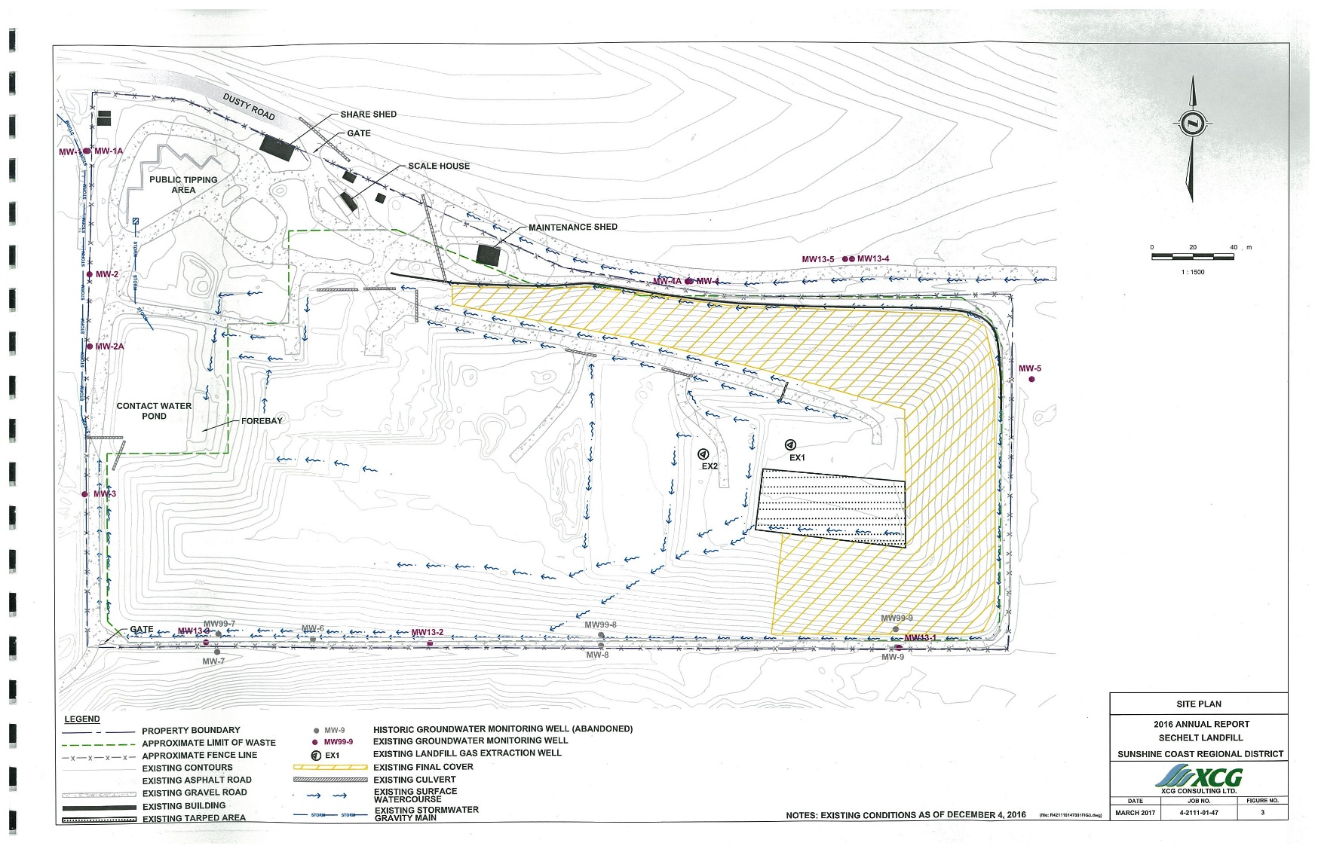
Area of the Sechelt Landfill with public and commercial traffic.

Appendix 3 – Site Map for Pender Harbour Transfer Station

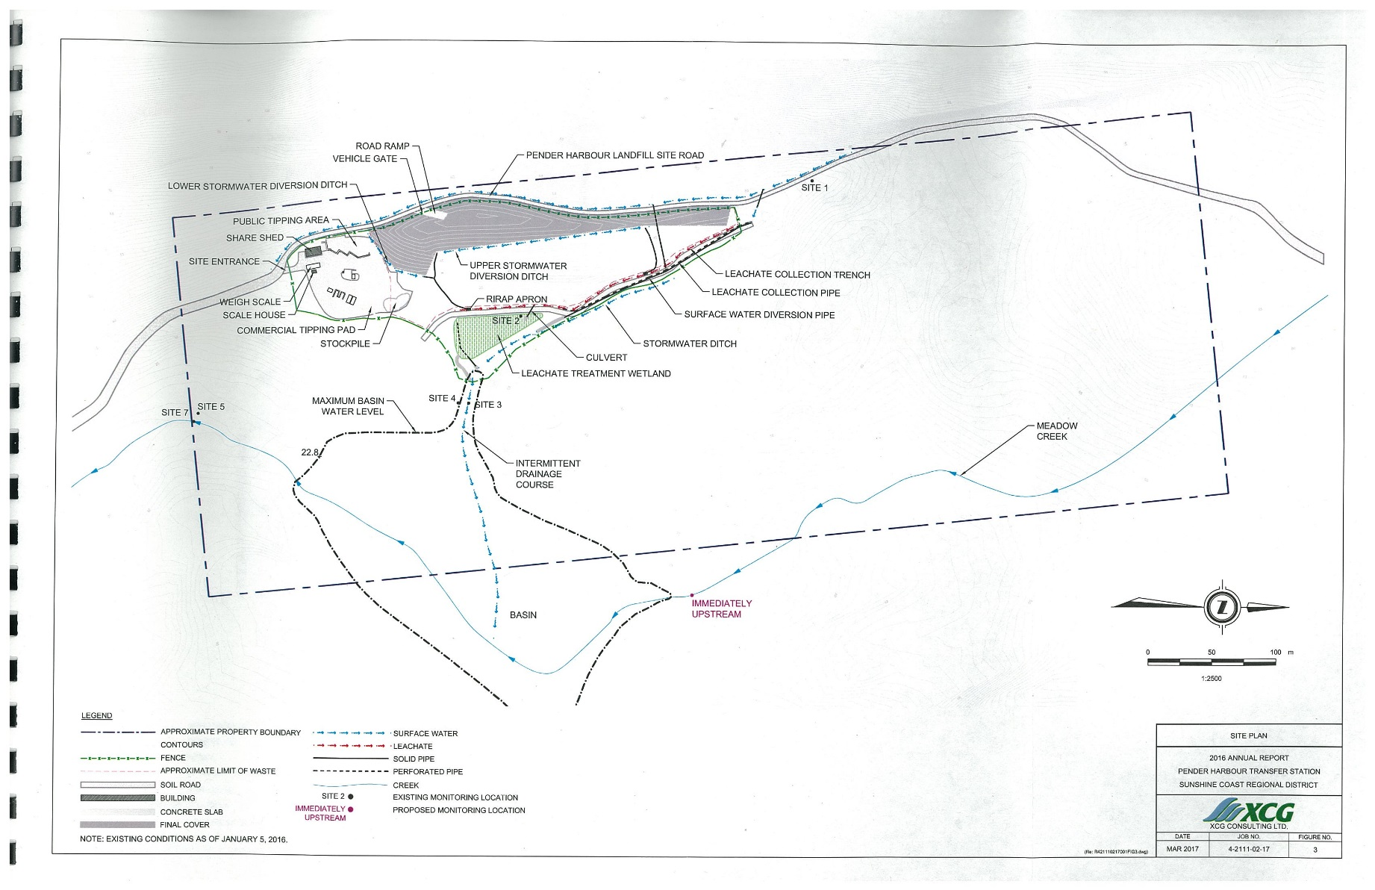
Area of the Pender Harbour Transfer Station with public and commercial traffic.
Appendix 4 – Current Site Hours of Operation

 | Sechelt Landfill | Pender Harbour Transfer Station
 | Year Round | Victoria Day long weekend to Labour Day long weekend inclusive | Winter  Sep 13, 2020 - May 16, 2021
Statutory Holidays | Closed  Stat Holidays Thanksgiving to Easter Monday | Open | Closed  Stat Holidays Thanksgiving to Easter Monday
Sunday | 12:00pm – 5:00pm | 8:30am – 4:30pm | Closed
Monday | Closed | 8:30am – 4:30pm | 8:30am – 4:30pm
Tuesday | 8:30am – 5:00pm | Closed | Closed
Wednesday | 8:30am – 5:00pm | 8:30am – 4:30pm | 8:30am – 4:30pm
Thursday | 8:30am – 5:00pm | 8:30am – 4:30pm | 8:30am – 4:30pm
Friday | 8:30am – 5:00pm | 8:30am – 4:30pm | 8:30am – 4:30pm
Saturday | 8:30am – 5:00pm | 8:30am – 4:30pm | 8:30am – 4:30pm

Appendix 5 – Sample Fuel and GHG Report
Month: | February | 2017
GHG Emissions
Equipment & Routes |  |  | Diesel
Date | Vehicle # | Route | Kms | amount  (Litres) | GHGs  (tCO2e)
Feb 1/17 | 111 | 3 | 65 | 75 | 0.204
 | 222 | 4 | 114 | 85 | 0.231
Feb 2/17 | 111 | 5 | 79 | 87.5 | 0.238
 | 222 | 6 | 80 | 86 | 0.234
 | 333 | 7 | 84.5 | 102 | 0.278
07-Feb | 111 | 1 | 120 | 100 | 0.272
 | 333 | 2 | 76.8 | 117 | 0.319
08-Feb | 111 | 4 | 93 | 70 | 0.191
 | 222 | 3 | 65 | 70 | 0.191
09-Feb | 111 | 6 | 80 | 90 | 0.245
 | 222 | 7 | 72 | 80 | 0.218
 | 333 | 5 | 80 | 70 | 0.191
14-Feb | 111 | 2 | 83.5 | 70 | 0.191
 | 222 | 1 | 120 | 90 | 0.245
15-Feb | 111 | 4 | 115 | 80 | 0.218
 | 222 | 3 | 70 | 75 | 0.204
16-Feb | 111 | 7 | 84.5 | 94 | 0.256
 | 222 | 6 | 85 | 90 | 0.245
 | 333 | 5 | 90 | 85 | 0.231
23-Feb | 111 | 5 | 82 | 92 | 0.251
 | 222 | 6 | 75 | 79.7 | 0.217
 | 333 | 7 | 84.2 | 84 | 0.229
 |  |  | 2276.3 | 2254.2 | 6.139

Appendix 6 – Sample Invoice Summary Sheet

Outbound from Regional District site |  |  |  | Inbound at Recycler
Date | Site | Ticket #  or Bill of Landing | # of Units | Date | Site | Ticket # or Bill of Landing | # of Units
May 3, 2017 | SL | 12356 | 130 | May 4, 2017 | SL | 99999 | 130
May 10, 2017 | SL | 654321 | 129 | May 11, 2017  SAMPLE | SL | 88888 | 129
May 23, 2017 | SL | 99999 | 133 | May 24, 2017 | SL | 11111 | 133

