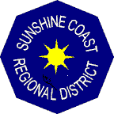

SUNSHINE COAST REGIONAL DISTRICT

Question and Answers #6
Request for Proposal No. 2337014
Exposed Intake Line Trestles Rehabilitation
Date: October 3, 2023
Item No.1
Question:
Can you confirm expected Timeline for the work? e.g., Expected Award Date, Expected Start and completion dates?
Answer:
The Regional District plans to make a recommendation to the Committee of a Whole in November and anticipates a board recommendation on November 23, 2023. It is anticipated that the Contract will start December 15, 2023, and run to January 31, 2024. Proponents are to propose their schedule as part of their submission.

